Lab 10 ReLe
Olaru Gabriel Iulian, 334 CC

EX 1:

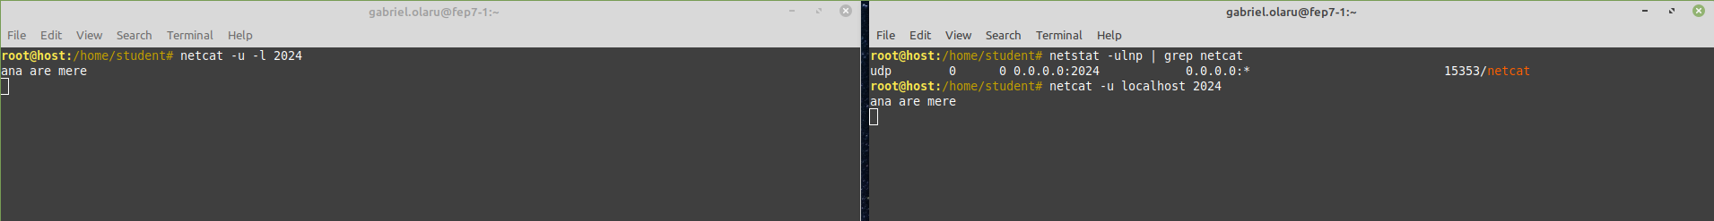

EX 2:

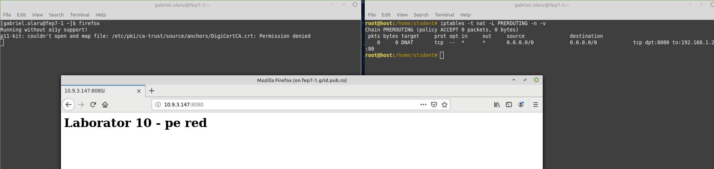

EX3:

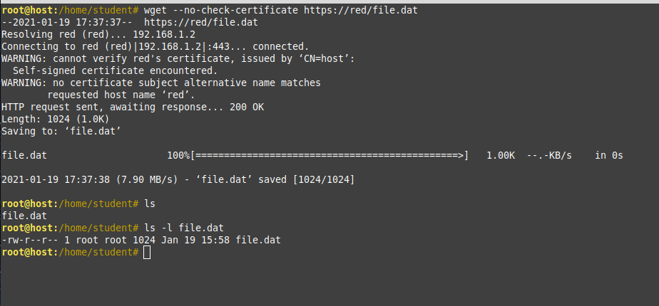

EX4:

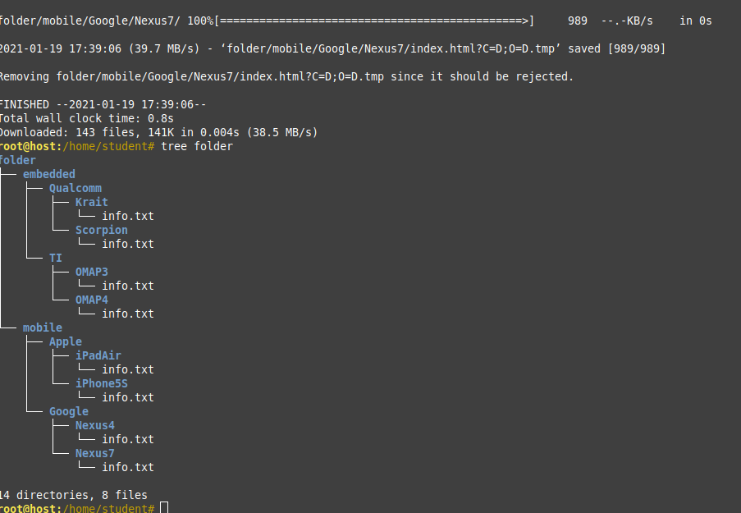

EX5:

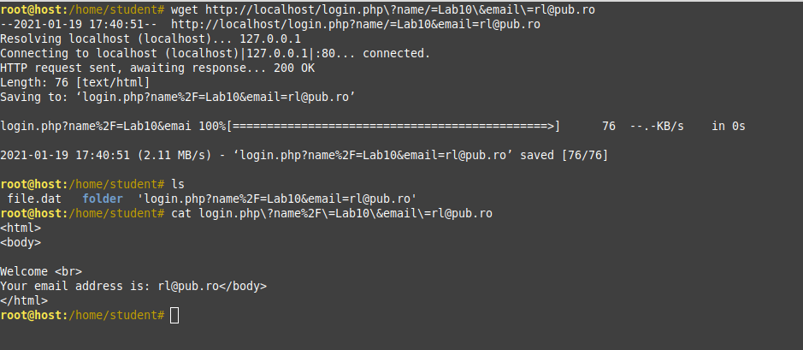
EX6:

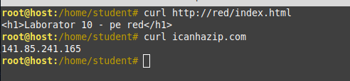

EX7:

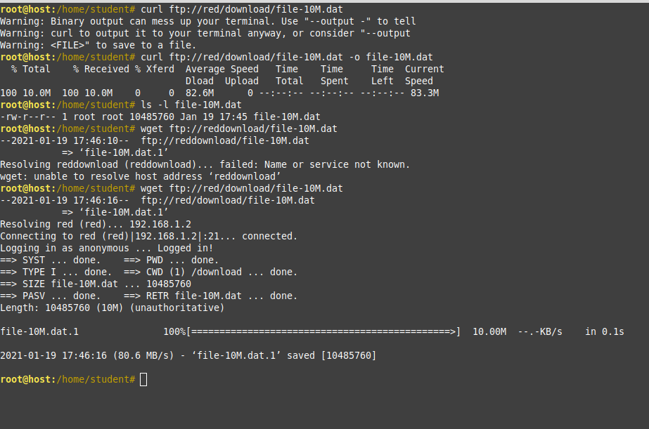

EX8:

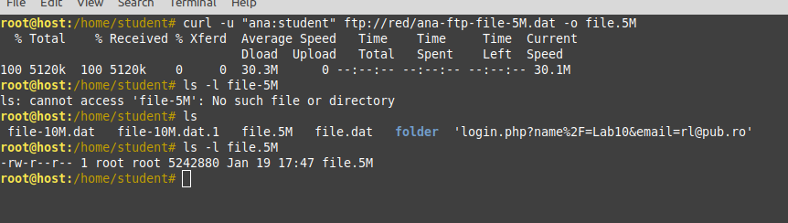

EX9:

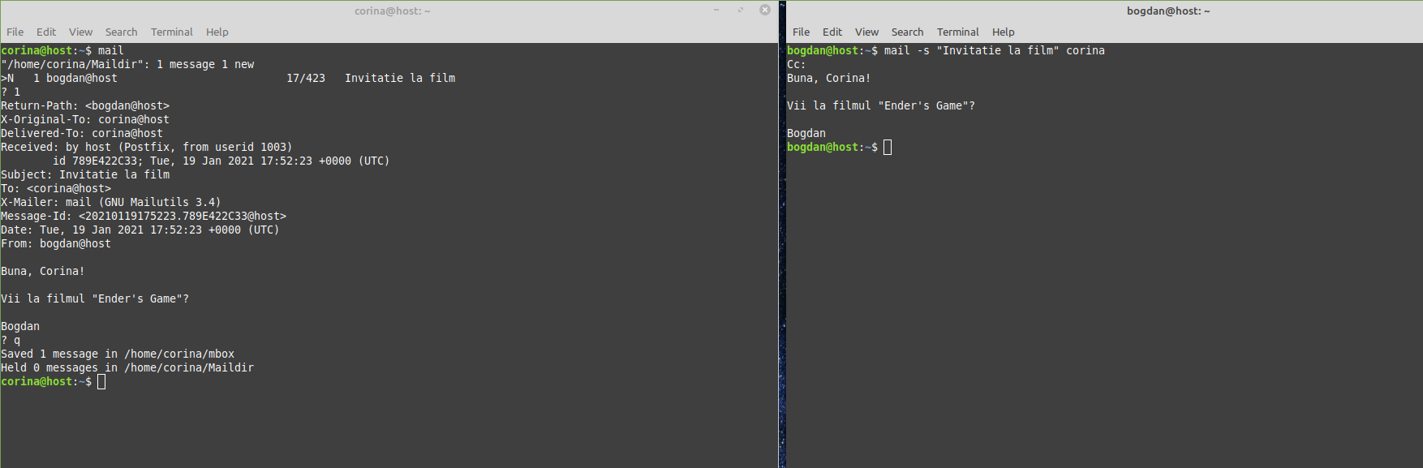

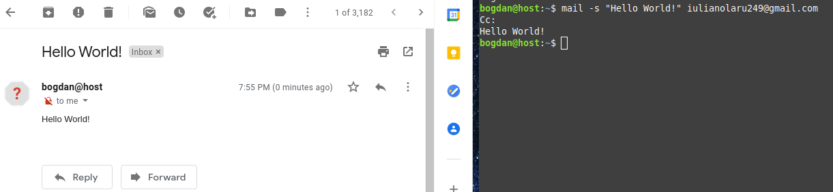

EX10:

